Funding would allow us to re-open our doors for public events knowing that the building provides a safe and welcoming venue. To ensure this we need to:

* Re-slate parts of the church roof
* Repair leaded windows
* Upgrade the fire-alarm system and
* Install more energy-efficient lighting

We would also like to:

* Commission war memorial plaques to re-insert into the wood panelling (to replace those removed from Overton Church to West Kilbride Parish Church)
* Repair the pipe organ
* Renovate the church bell so that it can be rung as intended
* Buy back the altar table, altar chairs and font which were sold during the union – or purchase replacement ones if this is not possible

The pipe organ and the church bell are the last of each in the village, all others having been removed previously.

If, between us, we can achieve the above, then we would aim to re-open Overton for events such as weddings, funerals, literary and musical events and afternoon teas. We would especially like to honour the wishes of one of our late key supporters in hosting a centenary organ recital in March 2021, marking just one of the many contributions made by his ancestors to the original establishment and ongoing upkeep of this beautiful property.

To become a ‘Friend of Overton’ please complete and return the form (if one is attached), visit our website, or contact us at the following address:

Overton, 50 Ritchie Street, West Kilbride, Ayrshire, KA23 9HF www.timberbooks.co.uk/friends *(1/20)*

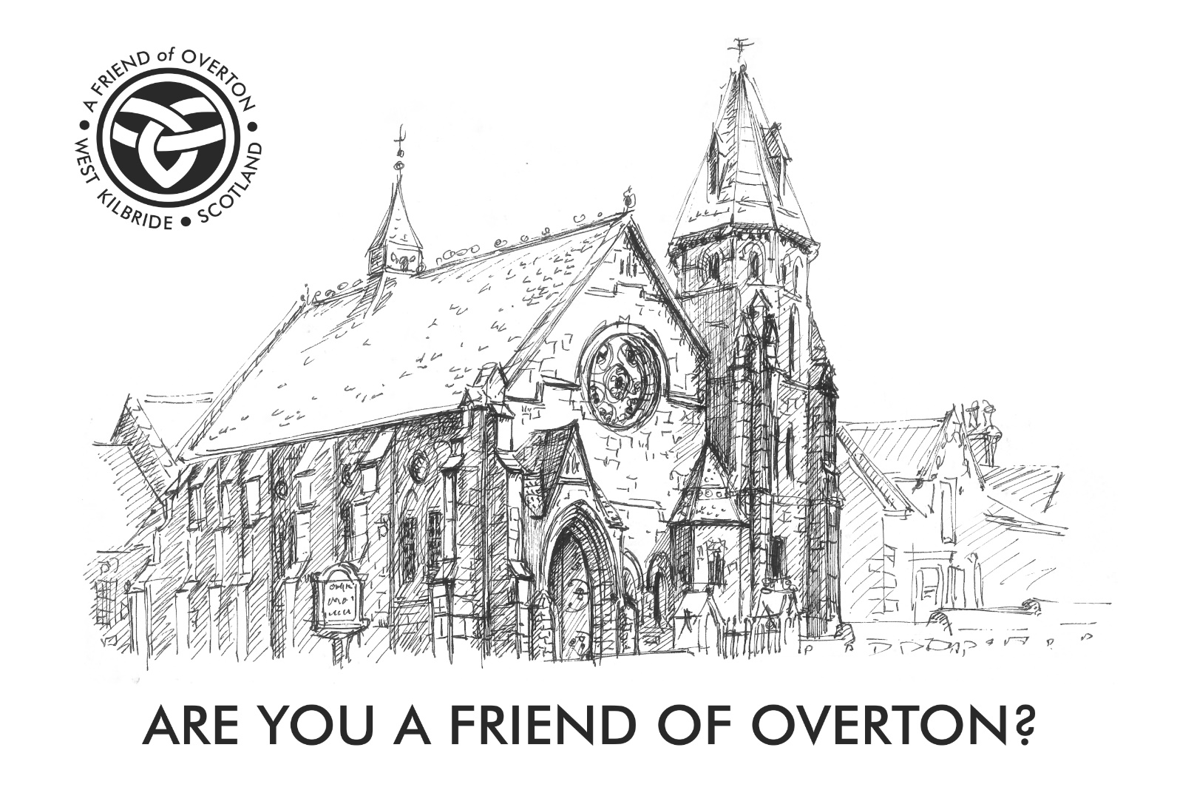

Why are we asking? In 2010 the Church of Scotland decided to unite the congregations of Overton and St Andrew’s Churches in West Kilbride and to sell Overton church and church hall. In 2013, after more than 18 months on the market, and with no other offers having been received, the property was bought by Timberbooks and re-opened as a bookshop and arts venue.

In addition to offering a retail bookshop (the last bookshop in North Ayrshire!), for the next three years we hosted public concerts, art exhibitions, and author visits in the church and church hall. In April 2016, following a complete renovation of the kitchen, our teashop (Ayrshire Tea House) also opened within the property.

The business was finally beginning to make enough money to cover the significant overheads which come with ownership of a listed building when, on 1 April 2017, we were hit with a £5,500 annual increase in our business rates. With no possible way to make the huge increased profit needed to pay this amount, and after trying all avenues to contest it whilst continuing to work a 70-hour week, we finally closed the buildings to the public on 31 July 2017.

Since then we have attempted to keep the buildings wind- and water-tight by bookselling both online and at off-site events, working in partnership with schools, libraries and local festivals. Sadly, the reduced income has meant that Overton has no longer been accessible to the public because other ongoing maintenance and renovation costs have not been affordable.

What are we asking for? Since we were forced to close we have been offered financial help by some incredibly generous local people, but have not wanted to accept this until we could offer something - even a token something - in return. We now feel that we are able to do this.

A small gift in return Michèle, owner of Timberbooks and of Overton, has worked with Tom, a top designer bookbinder based in Irvine, to design and craft a small range of ‘Friends of Overton’ items. These items, all hand-made using traditional book-binding techniques, can only be obtained by becoming A Friend of Overton 2020. *(For donations of £250 or more, we will be happy to agree a bespoke package featuring ‘A Friend of Overton’ logo.)*

|  |  |
| --- | --- |
|  | * For a donation of £25: Two bookmarks, individually hand- crafted from leather (chosen from a small range of colours) and embossed with ‘A Friend of Overton’ logo and ‘MMXX’ * For a donation of £50: A hand-crafted buckram notebook (chosen from a small range of colours), embossed with ‘A Friend of Overton’ logo, enclosing an A7 notepad which has been hand-made using recycled paper * For a donation of £75: A hand-crafted leather notebook in dark green ‘highland goat’, embossed with ‘A Friend of Overton’ logo, enclosing an A7 notepad which has been hand-made using recycled paper (or buckram version in A6) * For a donation of £100: A hand-crafted leather notebook in dark green ‘highland goat’, embossed with ‘A Friend of Overton’, enclosing an A6 notepad, hand-made using recycled paper |